SQL Task

SQL Lesson 13: Inserting Rows

1. Add the studio's new production, **Toy Story 4** to the list of movies (you can use any director)

Solution : **insert into Movies values(4, 'Toy Story 4' , 'John Lasseter' , 2020, 100 )**

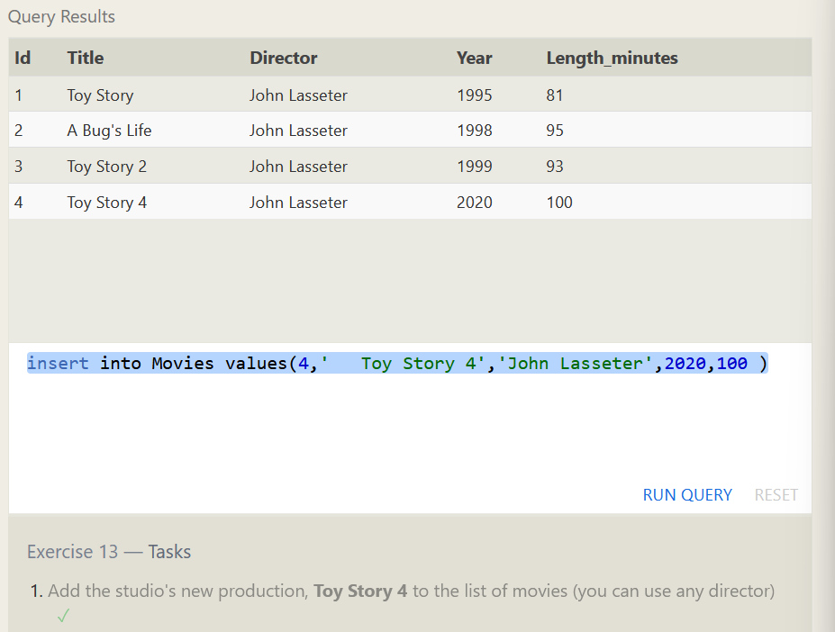

2. Toy Story 4 has been released to critical acclaim! It had a rating of **8.7**, and made **340 million domestically** and **270 million internationally**. Add the record to the BoxOffice table.

Solution: **insert into Boxoffice values (4, 8.7,340000000,270000000)**

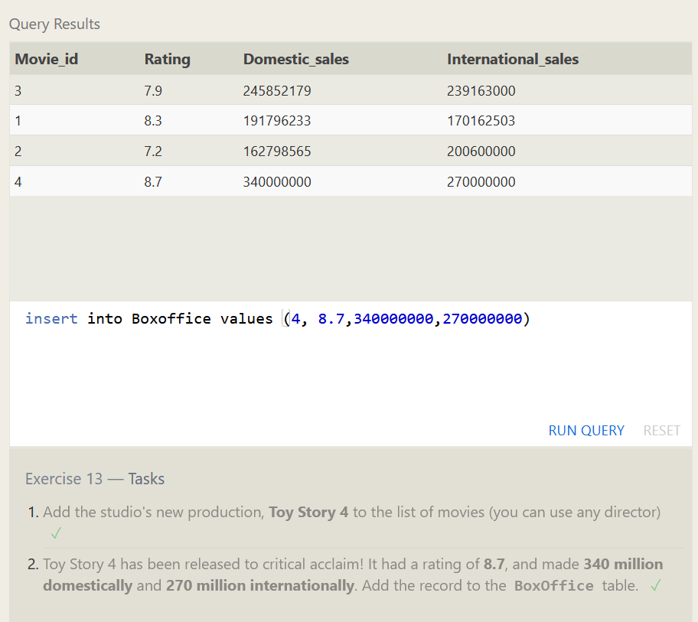

SQL Lesson 14. Updating Rows

1. The director for A Bug's Life is incorrect, it was actually directed by **John Lasseter**

**Solution: update Movies set Director = 'John Lasseter' where id= 2**

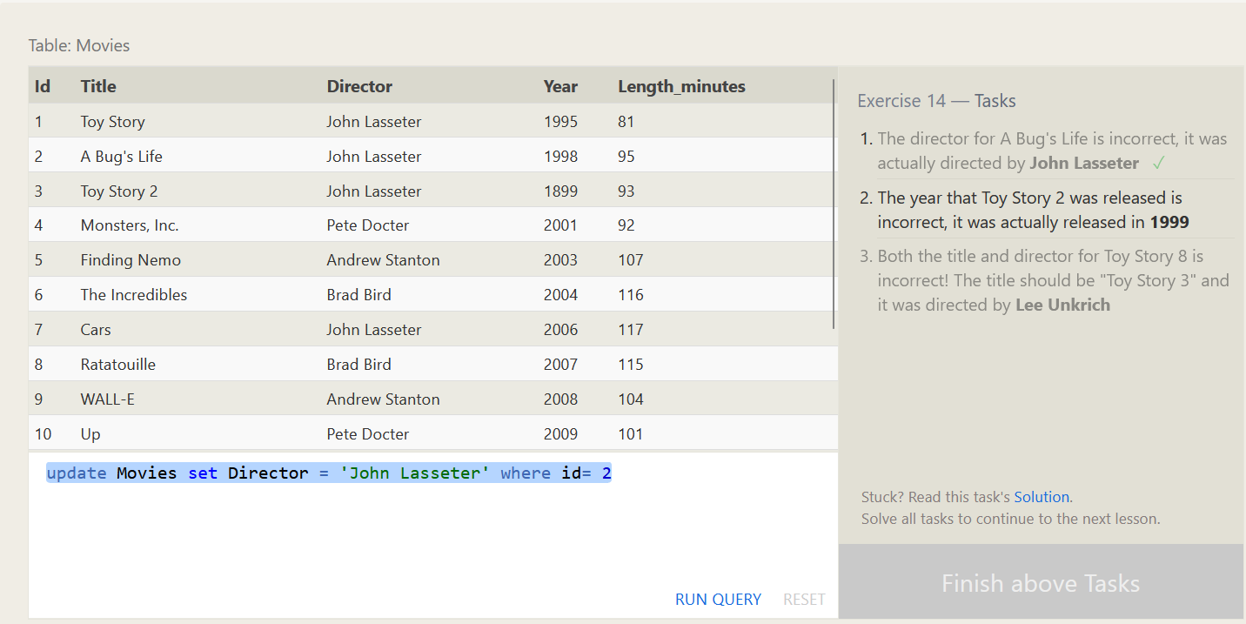

2. The year that Toy Story 2 was released is incorrect, it was actually released in **1999**

**Solution : update movies set Year= 1999 where id=3**

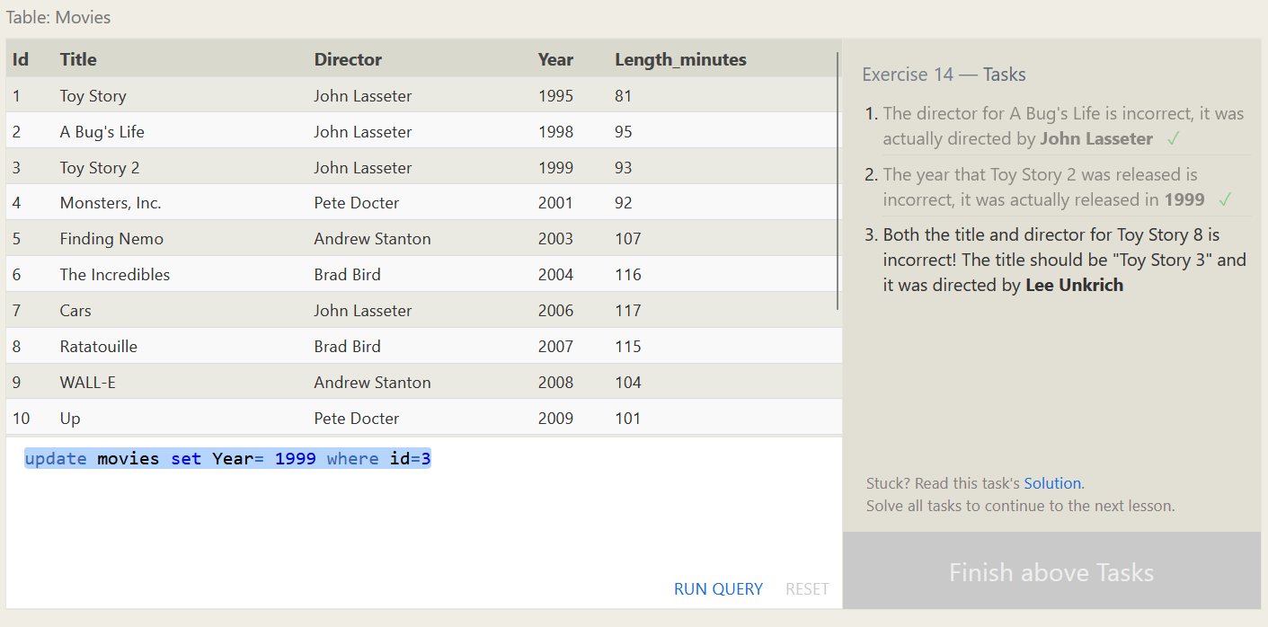

3. Both the title and director for Toy Story 8 is incorrect! The title should be "Toy Story 3" and it was directed by **Lee Unkrich**

**Solution: update Movies set Title= 'Toy Story 3', Director = ' Lee Unkrich' where id=11;**

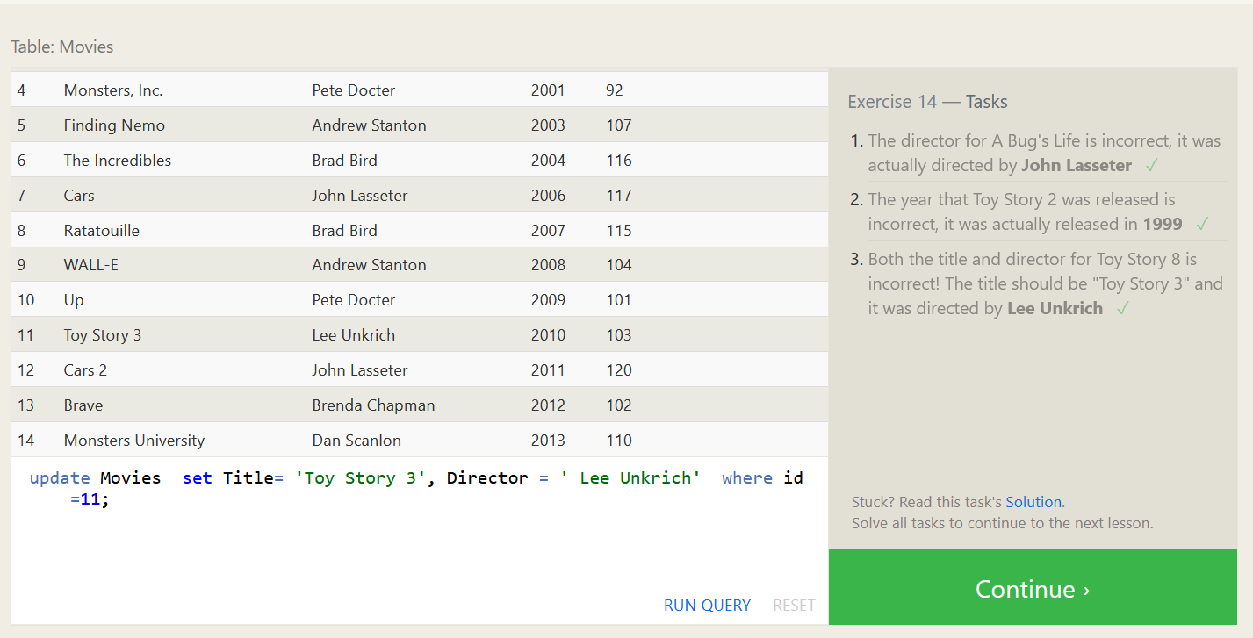

**SQL Lesson 15: Deleting rows**

**1 .** **This database is getting too big, lets remove all movies that were released before 2005.**

**Solution : DELETE FROM movies where year < 2005;**

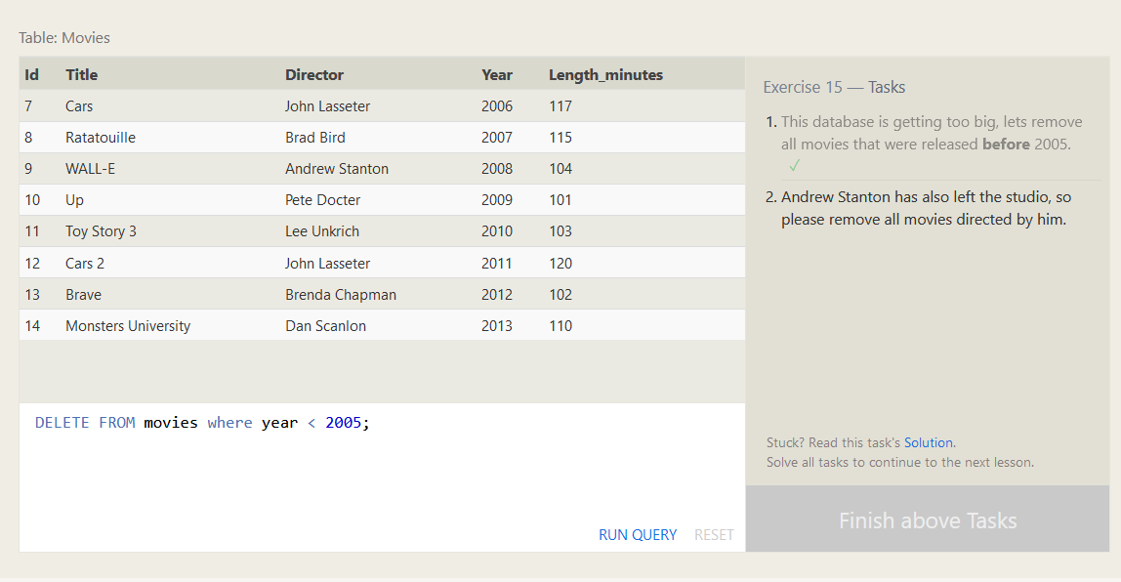

**2. Andrew Stanton has also left the studio, so please remove all movies directed by him.**

**Solution : delete from Movies where Director = ‘Andrew Stanton';**

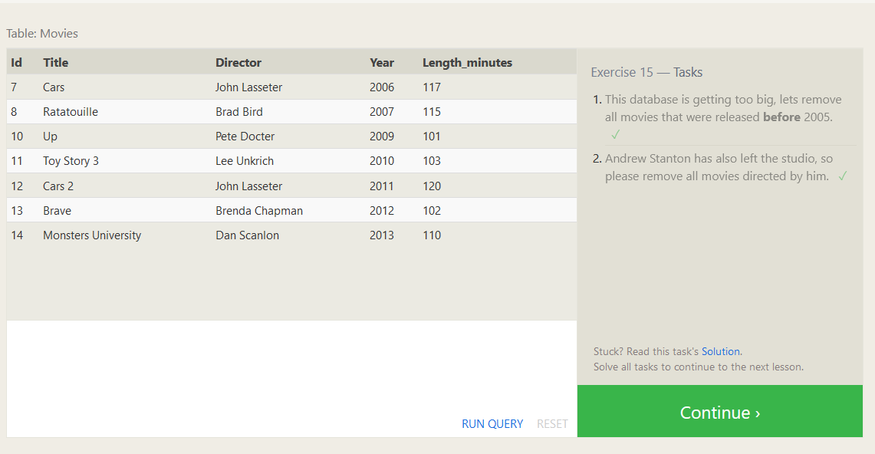

**SQL Lesson 16: Creating tables**

**1. Create a new table named Database with the following columns:**

**– Name A string (text) describing the name of the database  
– Version A number (floating point) of the latest version of this database  
– Download count An integer count of the number of times this database was downloaded**

**This table has no constraints.**

**Solution: CREATE TABLE Database (**

**Name varchar(255),**

**Version FLOAT,**

**Download_count INT**

**);**

**Table Created**

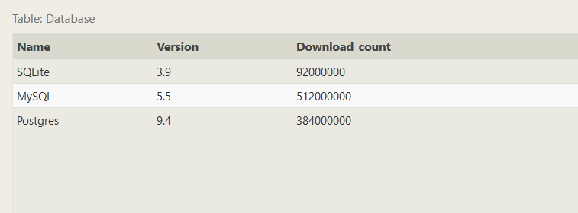

**SQL Lesson 17: Altering tables**

**1. Add a column named Aspect_ratio with a FLOAT data type to store the aspect-ratio each movie was released in.**

**Solution: ALTER TABLE Movies ADD COLUMN Aspect_ratio FLOAT DEFAULT 2.39;**

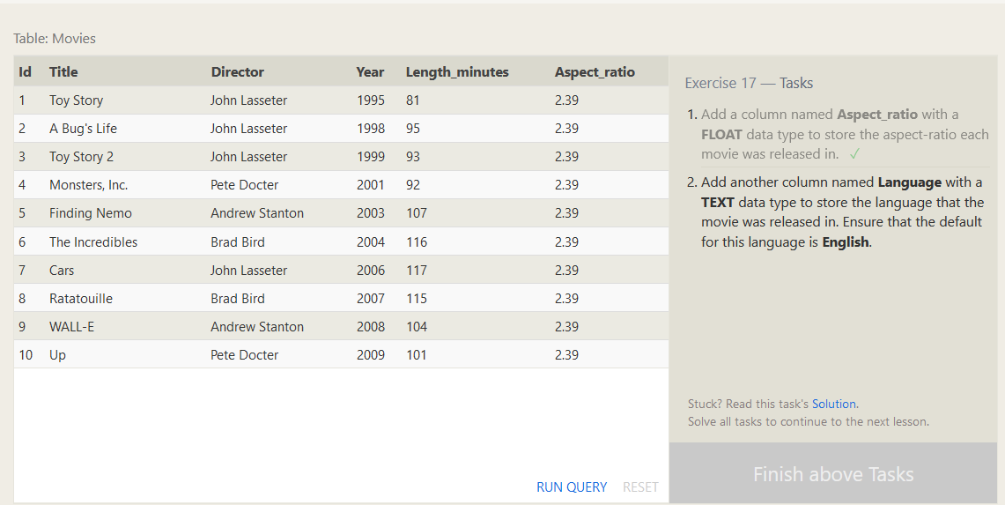

**2. Add another column named Language with a TEXT data type to store the language that the movie was released in. Ensure that the default or this language is English.**

**Solution: ALTER TABLE Movies ADD COLUMN Language TEXT DEFAULT "English";**

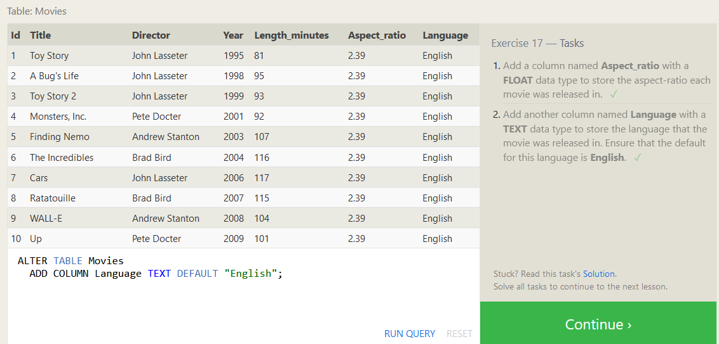

**SQL Lesson 18: Dropping tables**

**1. We've sadly reached the end of our lessons, lets clean up by removing the Movies table**

**Solution : DROP TABLE Movies;**

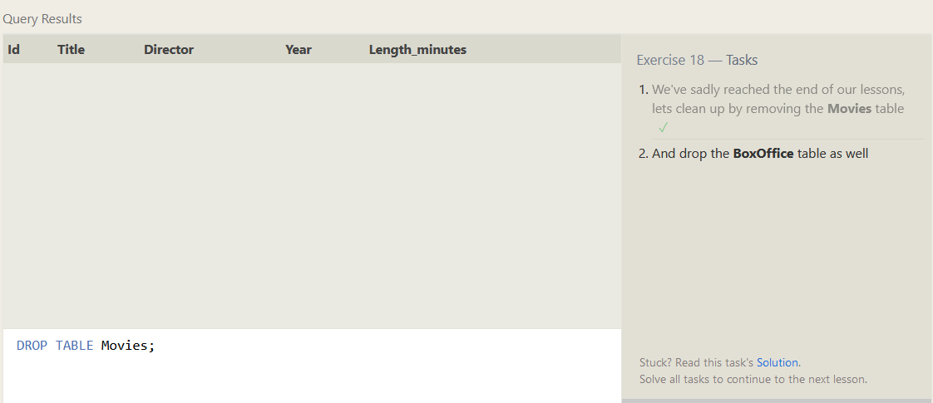

**2. And drop the BoxOffice table as well**

**Solution: DROP TABLE BoxOffice;**

